SKILL WEEK-1
Session -1
Task1: To Install Linux VM, Configure GCC, Setup Git Repository, Create Project Structure, Understand Shell Architecture, Build Initial Makefile.
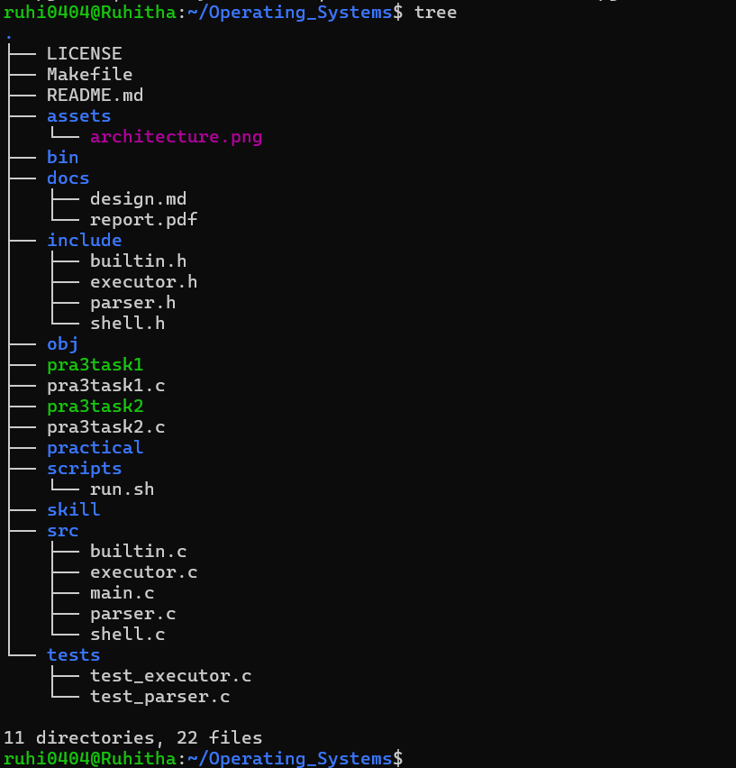
Observation:
The Linux development environment was successfully set up and the project directory structure was created. GCC and Git were configured and verified. The project was organized into separate directories for source files, header files, object files, scripts, tests, documentation, and other project resources. The initial MakeFile was also created to support automated compilation and build management. The shell architecture and organization of the Linux project environment were understood.

Task2: To Analyse process abstraction, execute fork(), understand exec() family, analyse parent-child relationships, inspect process tree, and practice system call tracing.
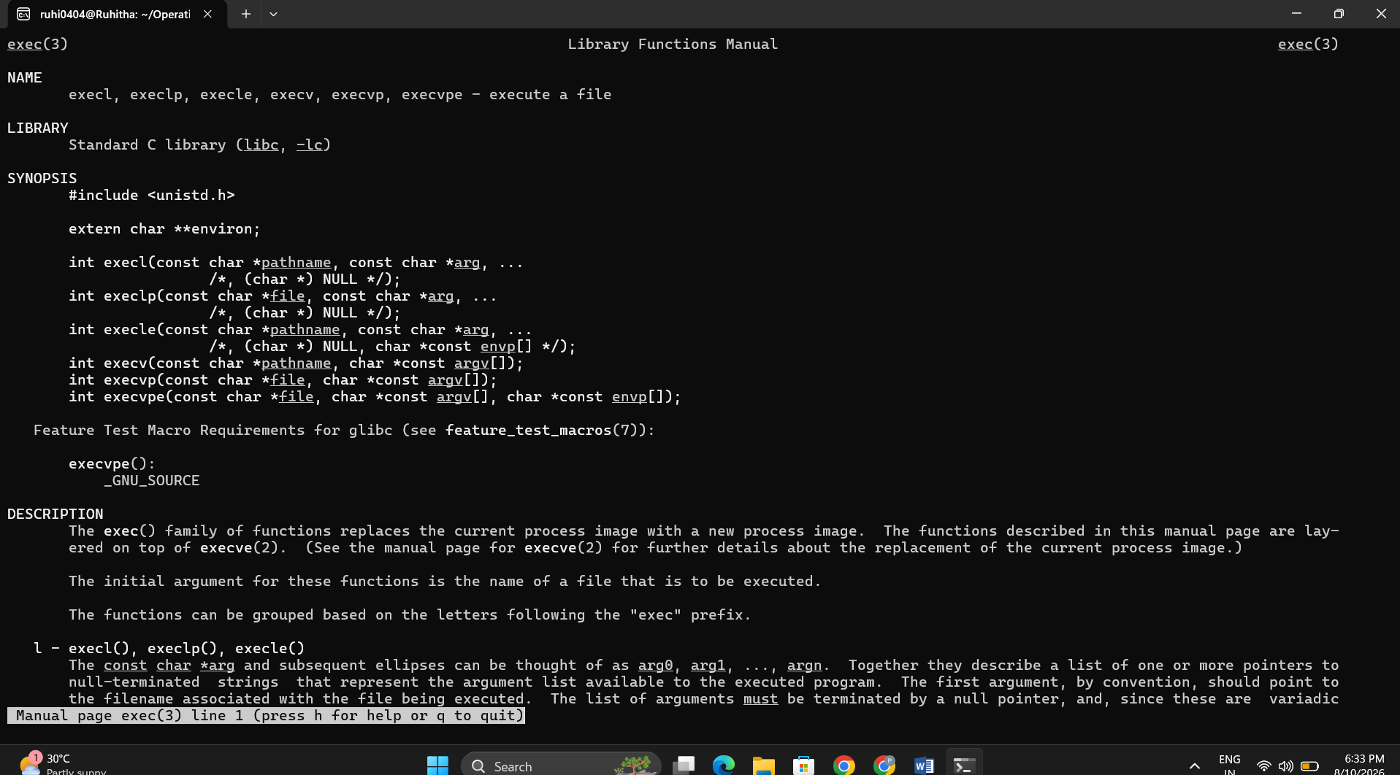
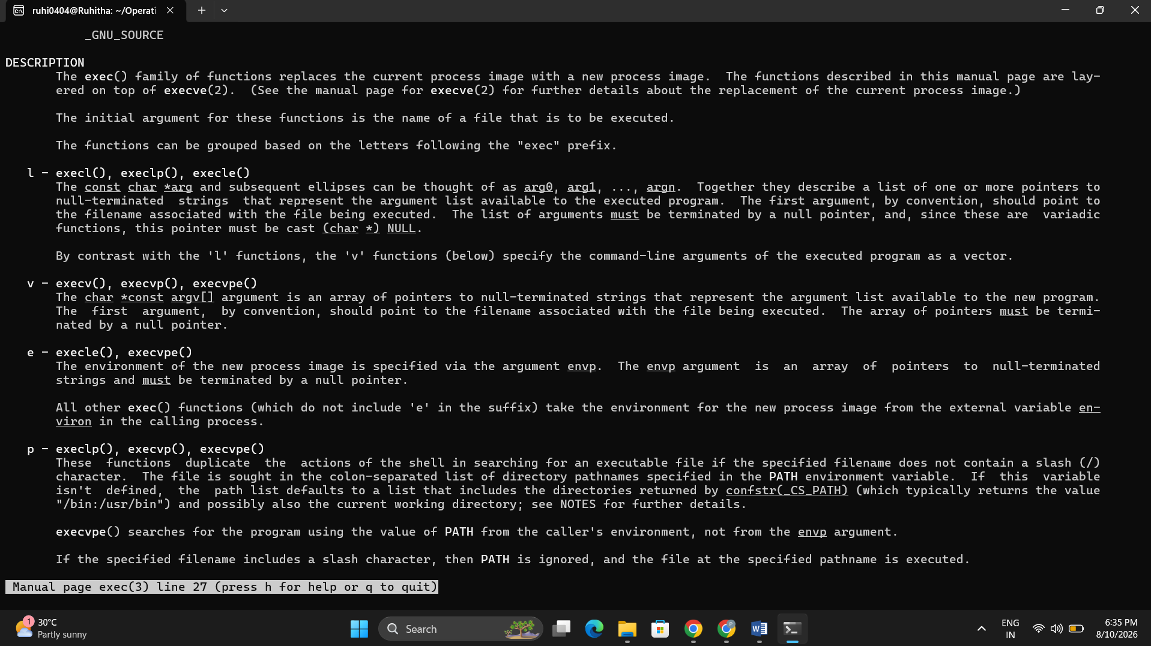
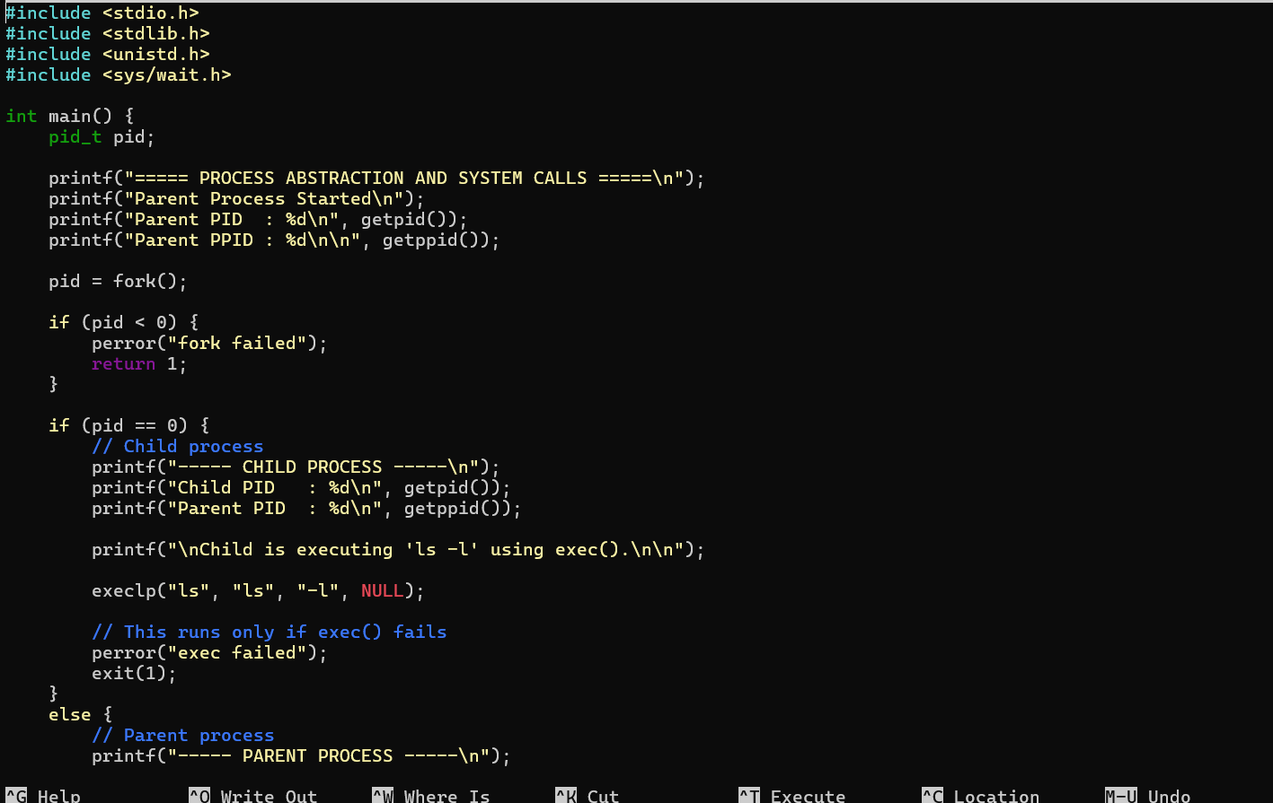
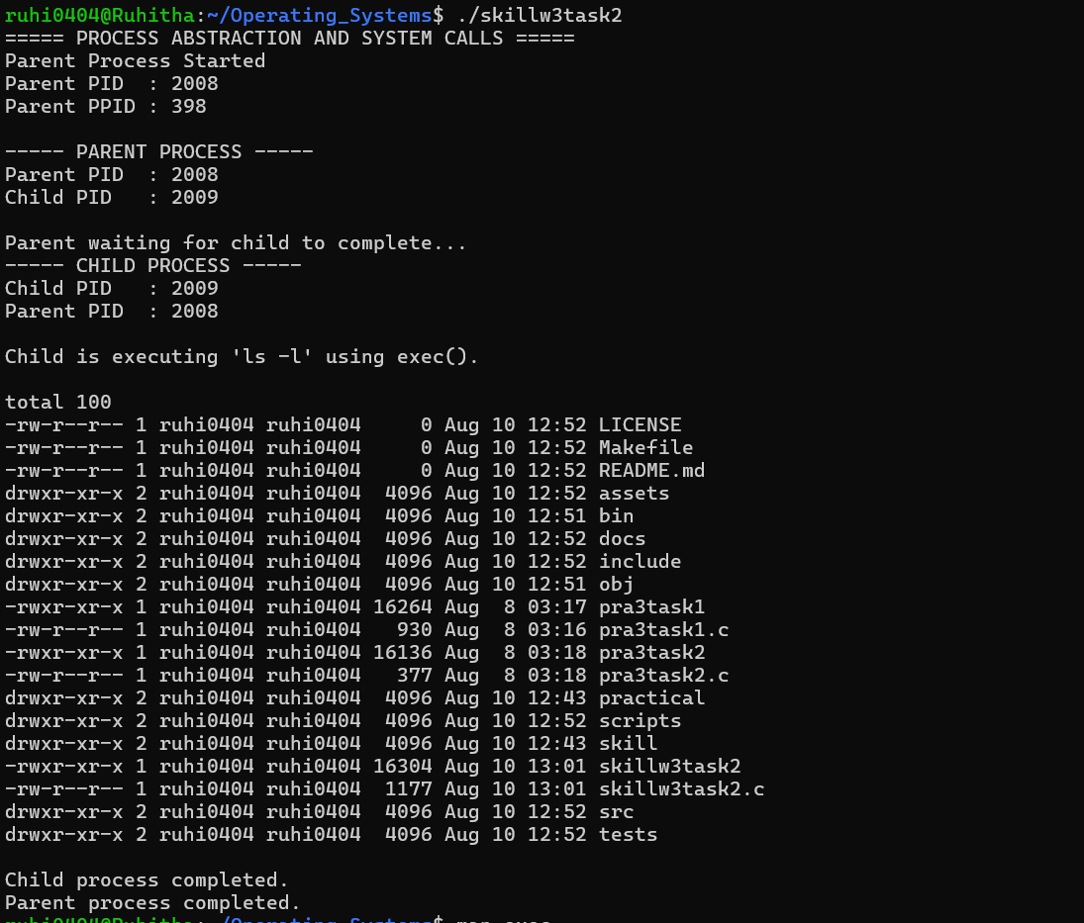
Observation: The process abstraction was successfully analysed using fork(), creating a parent-child process relationship. The exec() family was used to execute a new program in the child process, while wait() allowed the parent process to wait for the child to complete. The process hierarchy was inspected using process-tree commands, and system calls were successfully traced using strace.
Session -2
Task1: To Create Main Loop, Display Prompt, Read User Input, Handle Exit Conditions, Design Control Flow Diagram, and Test Interactive Loop.
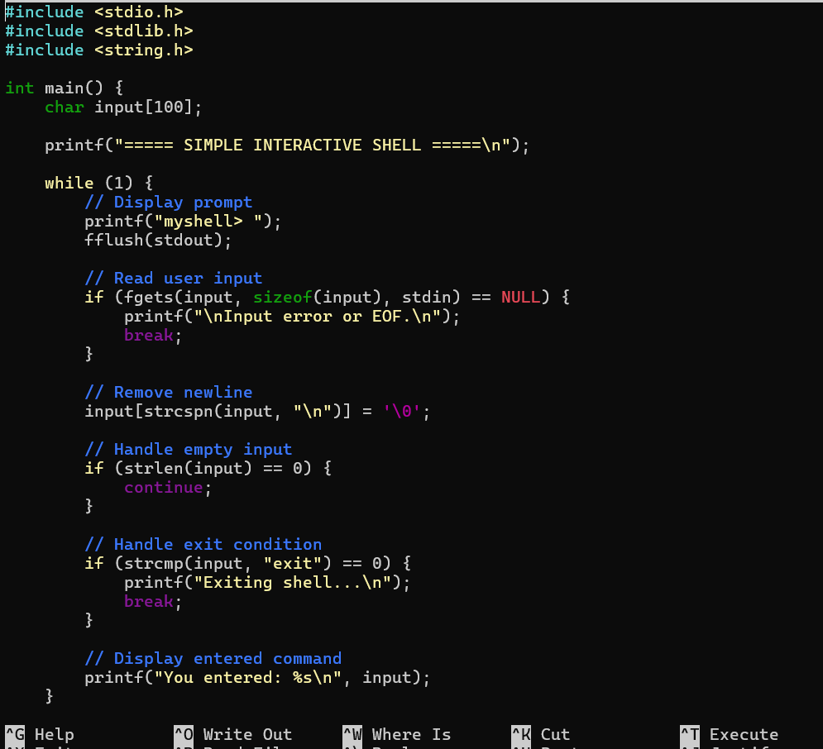
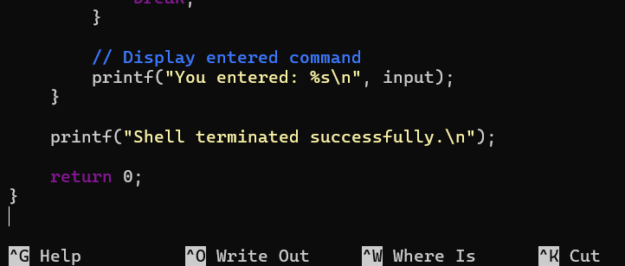
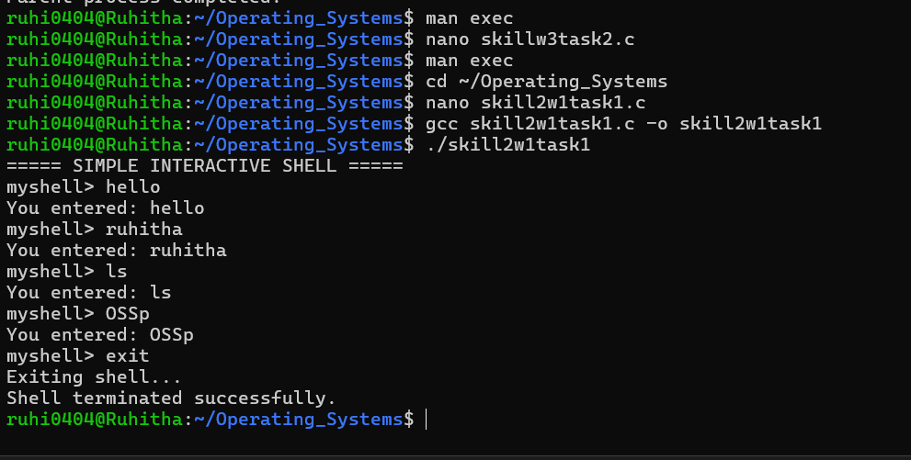Observation: The interactive shell loop was successfully created and tested. The program continuously displayed a prompt, accepted user input, and processed the entered commands. The exit condition was implemented to terminate the loop, demonstrating the basic control flow of an interactive shell.
Task 2: Capture Keyboard Input, Handle Backspace, Process Enter Key, Manage Input Buffer, Support Multi-Character Commands, Test User Interaction
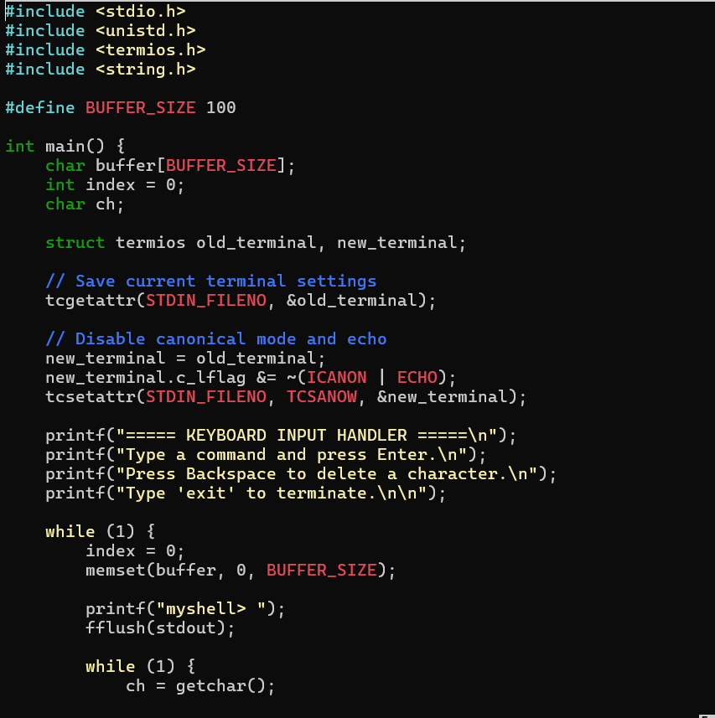
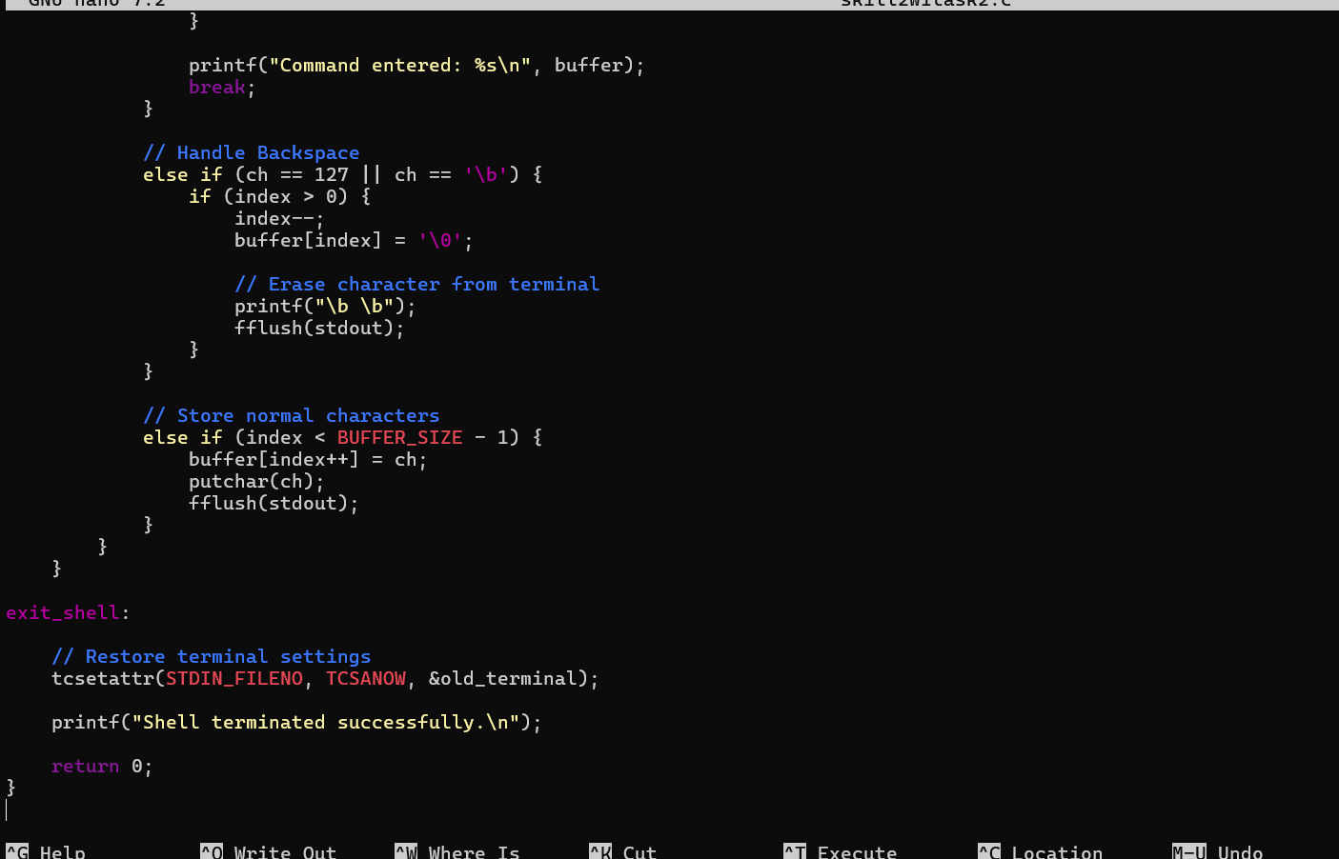
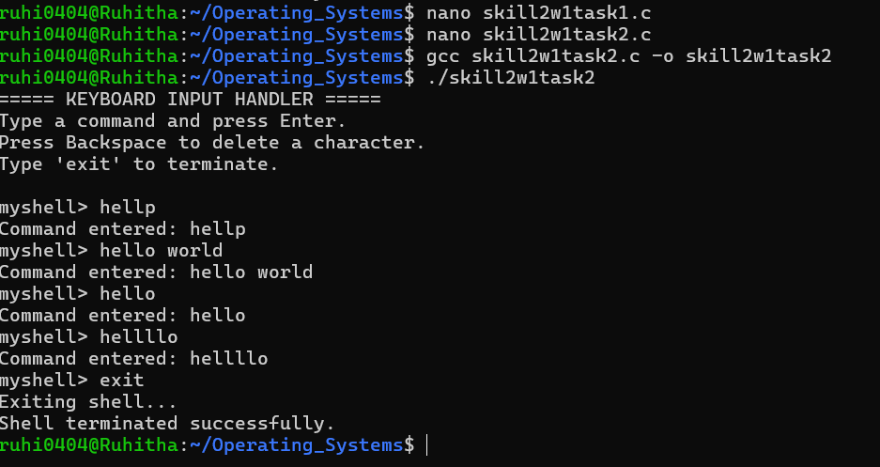
Observation: The keyboard input handler was successfully implemented using character-by-character input. The program maintained an input buffer, processed the Enter key to complete commands, and handled Backspace to remove previously entered characters. Multi-character commands were successfully accepted and displayed, and the exit command was used to terminate the interactive shell.

